**Homework # 4**

NATing1 (10 Points)

show ip route

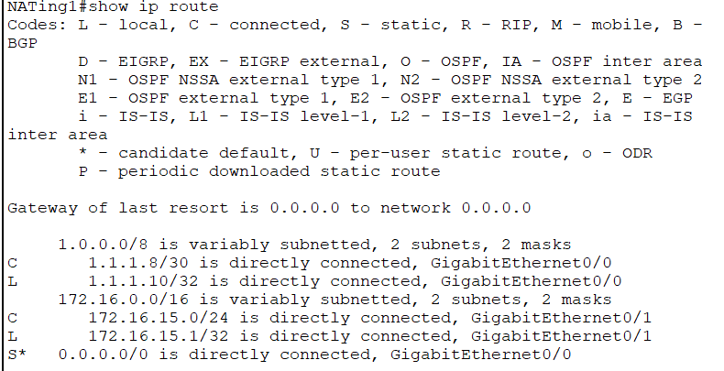

show run | sec nat

show ip nat statistics

show access-list

NATing2 (10 Points)

show ip route

show run | sec nat

show ip nat statistics

show access-list

Company (10 Points)

show ip route

show run | sec nat

show ip nat statistics

show access-list

ISP1(10 Points)

show ip route bgp

show ipv6 route

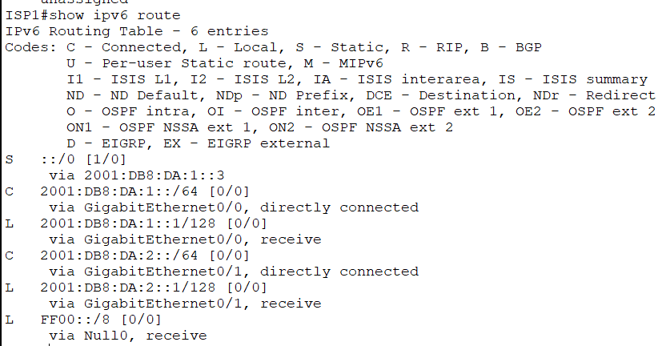

Pinging from ISP1 to ISP2

ISP-Entry-1 (15 Points)

show ip route bgp

show ip route eigrp

show ipv6 route

ISP-Entry-2 (15 Points)

show ip route bgp

show ip route eigrp

show ipv6 route

ISP2 (10 Points)

show ip route bgp

show ipv6 route

Pinging from ISP2 to ISP1

Inc. (10 Points)

show ip route

show run | sec nat

show ip nat statistics

show access-list

<There will be no access list as I have used Port Address Translation and Static Translation here>

Access the webservers from PC1 and show screenshot of the three webservers. (10 Points)

